7. The Black Sea and the Red Sea

Worksheet 2: The Black Sea and the countries around it
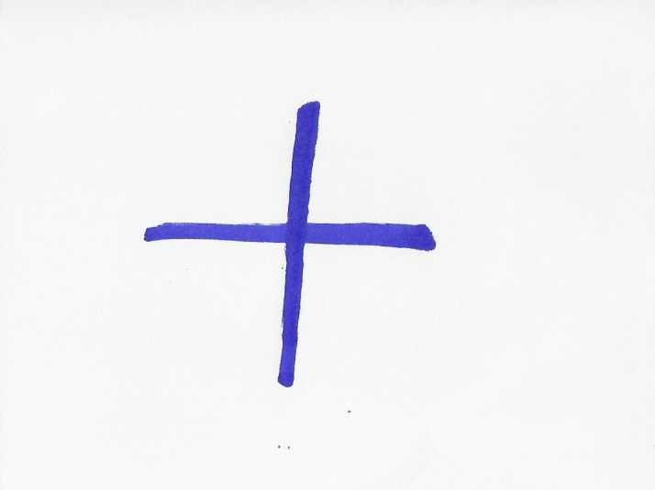Grouping:  (individual)
- Read some more information on the Black Sea, from the same sources:
In antiquity, the ancient Greeks used to call the Black Sea the 'Hospitable sea', Euxeinos Pontos (Εὔξεινος Πόντος). But this was a euphemism, in order to reverse the fact that the sea was difficult to navigate, due to frequent storms and because its shores were inhabited by savage tribes.
Today, all the peoples surrounding this deep water basin, call it by a name meaning “Black Sea” in their own language. (In the brackets you can see the original writing in the alphabet of the languages that do not use the Latin letters. The bold letters indicate where the stress is. Source: http://en.wikipedia.org/wiki/Black_Sea):
Greek Mavri Thalassa (Μαύρη Θάλασσα),
Bulgarian Cherno more (Черно море),
Georgian Shavi zghva (შავი ზღვა),
Romanian Marea Neagră,
Russian Chornoye more (Чёрное море),
Turkish Karadeniz,
Ukrainian Chorne more (Чорне море),

- Can you find out which of the above words mean “sea” and which ones mean “black?” (The Turkish name is a compound word). If you need help, you can use a translation site: http://www.athropolis.com/translate.htm
Language | Black | Sea
Greek | Mavri
Bulgarian |  | more
Georgian | Shavi
Romanian
Russian
Turkish
Ukrainian

Answer Sheet for B
Language | Black | Sea
Greek | Mavri | Thalassa
Bulgarian | Cherno | more
Georgian | Shavi | zghva
Romanian | Neagră | Marea
Russian | Chornoye | more
Turkish | Kara- | deniz
Ukrainian | Chorne | more

